Learning through Play in Kererū Class (Pukehou School’s New Entrant Class)

In Kererū class you may notice a difference in the way we operate. You will see dress-ups, blocks, animals and other loose parts to play with. There is also a comfy couch with loads of books to read, numbers all over the walls and various places for Kererū Kids to practise writing.

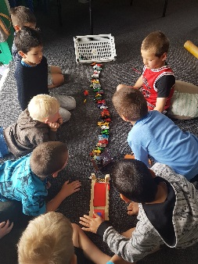
We believe play has a vital role in a child’s development. (Even as adults we play. Think of the first time you got your smartphone, smart tv, Ipad etc….what was the first thing you did? You ‘had a play’ to see how it worked.) Play is a natural part of a child’s life. Through play, children learn many skills that will set them up for deep learning later on in their schooling. While Kererū Kids play they are learning how to solve problems, manage themselves to make decisions, communicate their needs, share and negotiate….the list goes on.
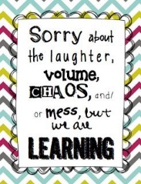
School is a long game and at 5 the most valuable thing we can provide is an environment that is enjoyable and engaging. Kererū class is designed to make the transition to school from ECE as smooth as possible. During the day Kererū Kids are given opportunities to self-direct their play, as well as more directed play, where I have more input. This is set up based on Kererū Kids interest levels, or with a particular concept we have that needs targeting. While Kererū Kids are engaged in their play, individuals or small groups are taken aside to work on skills such as reading, writing and mathematical concepts. This allows their needs to be met in a more direct and targeted way. Also there are times through the day
where whole class or larger instruction happens, for example: learning phonics/alphabet or shared book for reading.
A child learns best when they’re interested and a play-based approach allows us to hook into those interests.

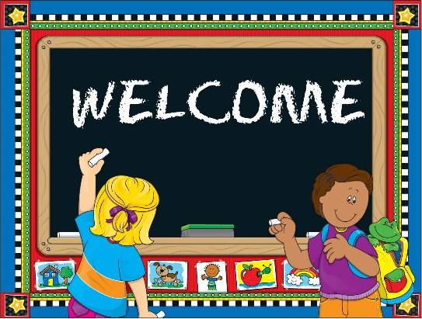
Kereru Class Open Days Term 4
For 4 year olds turning 5 soon and due to start school in Jan 2018.
Wednesday 15th, 22nd, 24th November 9.00 am– 3.00pm (Flexible times)
Please contact the office to register your interest.

